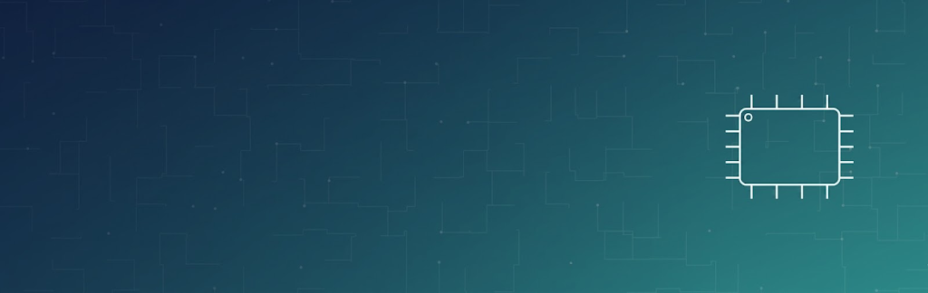

ASSIGNMENT REPORT
Digital Design
Setup & Hold Timing Analysis (STA)
Course | Digital Design
Assignment | STA — Setup/Hold Analysis of a Two-Path Combinational Network
Student Name | Mohamed Hossam El-Sawy
Instructor / TA | Eng.Temsah
Submission Date | 8/12/2026

01 OBJECTIVE
This assignment performs a static timing analysis (STA) on a synchronous path in which two launching flip-flops (FF1, FF2) drive a shared combinational network — an inverter, an XNOR gate and a NAND gate — that feeds a common capturing flip-flop, at a clock period of 5 ns. The goal is to verify whether the path meets both the setup and hold requirements, to compute the resulting slack (or violation), and, if a violation is found, to select and place a buffer from the available library to correct it.
02 PROBLEM STATEMENT / REQUIREMENTS
Two flip-flops (Tc2q1, Tc2q2) launch data into a combinational block built from an inverter, an XNOR gate and a NAND gate, connected by the interconnect (wire) delays shown on the schematic. The NAND output feeds the D input of a third flip-flop with setup time Tsu and hold time Thold. Interconnect delay is included; clock uncertainty is not considered; both worst-case (max) and best-case (min) corners of the gate/flip-flop library are given.
- Tperiod = 5 ns; clock uncertainty is not considered; interconnect (wire) delays are included in every path.
- For each of setup and hold: determine whether timing is met, and calculate the slack (positive) or violation (negative) — using max-corner delays for the setup check and min-corner delays for the hold check.
- If a violation exists, select the smallest suitable buffer from the library (BUF0 / BUF1 / BUF2), state where it should be inserted, and confirm that the fix does not create a new setup violation.
03 DESIGN & ANALYSIS
3.1 Timing Paths in the Circuit
The inverter's output fans out in two directions, so there are three distinct combinational paths from a launching flip-flop to the D input of the capturing flip-flop:
- Path 1: FF1 → wire(0.2) → INV → wire(0.7) → NAND → wire(0.1) → D
- Path 2: FF2 → wire(0.3) → XNOR → wire(0.1) → NAND → wire(0.1) → D
- Path 3: FF1 → wire(0.2) → INV → XNOR → wire(0.1) → NAND → wire(0.1) → D
Setup is governed by the longest (worst-case, max-delay) path, since the last signal to arrive is the one that risks missing the setup window. Hold is governed by the shortest (best-case, min-delay) path, since the earliest signal to arrive is the one that risks violating hold.
3.2 Setup (Max-Delay) Analysis
Each path delay is built from Tc2q(max) + wire delays + gate delays (max). The setup check compares the longest path's total delay, plus Tsu(max), against Tperiod.
Path | Tc2q (max) | Wire + Gate Delays (max) | Total Tpd (ns)
Path 1 | 0.4 | 0.2 + 0.5 (INV) + 0.7 + 1.0 (NAND) + 0.1 | 2.9
Path 2 | 0.5 | 0.3 + 1.5 (XNOR) + 0.1 + 1.0 (NAND) + 0.1 | 3.5
Path 3 (critical) | 0.4 | 0.2 + 0.5 (INV) + 1.5 (XNOR) + 0.1 + 1.0 (NAND) + 0.1 | 3.8
Path 3 is the setup-critical path (3.8 ns). Adding Tsu(max) = 0.8 ns:
Tpd(max) + Tsu(max) = 3.8 + 0.8 = 4.6 ns ≤ Tperiod = 5.0 ns
Result: Setup timing is MET, with slack = 5.0 − 4.6 = +0.4 ns (positive slack, no violation).
3.3 Hold (Min-Delay) Analysis
Each path delay is now built from Tc2q(min) + wire delays + gate delays (min). The hold check compares the shortest path's total delay against Thold — using Thold's own worst-case (max) value, since that is the safe sign-off corner.
Path | Tc2q (min) | Wire + Gate Delays (min) | Total Tpd (ns)
Path 1 (critical) | 0.3 | 0.2 + 0.3 (INV) + 0.7 + 0.8 (NAND) + 0.1 | 2.4
Path 2 | 0.4 | 0.3 + 1.2 (XNOR) + 0.1 + 0.8 (NAND) + 0.1 | 2.9
Path 3 | 0.3 | 0.2 + 0.3 (INV) + 1.2 (XNOR) + 0.1 + 0.8 (NAND) + 0.1 | 3.0
Path 1 is the hold-critical (shortest) path, Tpd(min) = 2.4 ns.
Real / sign-off analysis — uses Thold(max) = 2.8 ns: slack = 2.4 − 2.8 = −0.4 ns → hold VIOLATION.
Naive / mis-corner tool analysis — uses Thold(min) = 2.0 ns: slack = 2.4 − 2.0 = +0.4 ns → appears to pass, but this is not a valid sign-off corner.
Result: Using the correct (max Thold) corner, Path 1 has a real hold violation of −0.4 ns and must be fixed.
3.4 Fixing the Hold Violation
Path 1 is too fast, so extra delay must be inserted in series on Path 1 only — specifically on the branch between the inverter's output and the NAND input, since that branch does not feed the XNOR gate and therefore will not add delay to Path 2 or Path 3. The minimum extra delay needed is 0.4 ns, measured on the buffer's min-delay rating (the hold check uses min-corner values).
Buffer | Min Delay (ns) | Max Delay (ns) | Resolves 0.4 ns Gap?
BUF0 (chosen) | 0.4 | 0.6 | Yes — exactly meets the 0.4 ns requirement
BUF1 | 0.8 | 1.1 | Yes, but adds unnecessary extra delay
BUF2 | 1.3 | 1.4 | Yes, oversized for this fix
BUF0 is the smallest buffer that closes the gap, so it is the correct choice — it fixes the violation while adding the least possible delay to the setup path.
Verification after inserting BUF0 on Path 1 only:
- Hold: Tpd1(min) + BUF0(min) = 2.4 + 0.4 = 2.8 ns = Thold(max) → slack = 0 ns (violation resolved).
- Setup: Tpd1(max) + BUF0(max) = 2.9 + 0.6 = 3.5 ns, still below the setup-critical Path 3 (3.8 ns) → setup slack stays +0.4 ns, unaffected.
Location: insert BUF0 in series on the inverter-output-to-NAND segment of Path 1, downstream of the fan-out point that feeds the XNOR gate — this confines the extra delay to the hold-violating path only.
04 RESULTS SUMMARY
Check | Critical Path | Path Delay (ns) | Requirement (ns) | Slack (ns) | Status
Setup | Path 3 | 3.8 (+0.8 Tsu) | Tperiod = 5.0 | +0.4 | MET
Hold (before fix) | Path 1 | 2.4 | Thold = 2.8 | -0.4 | VIOLATED
Hold (after BUF0) | Path 1 | 2.8 | Thold = 2.8 | 0.0 | MET
05 DISCUSSION
The setup check passes comfortably because the setup-critical path (Path 3) is the longest electrical path — it goes through both the inverter and the XNOR before the NAND — leaving 0.4 ns of positive slack against the 5 ns period. The hold check fails because Path 1, the shortest path in the network, arrives at the capturing flip-flop before the required hold window closes when the flip-flop's worst-case hold time (2.8 ns) is used. This highlights a common STA pitfall: a hold check run against an overly optimistic Thold corner (2.0 ns here) would have hidden a real violation. Fixing the hold violation by inserting the smallest sufficient buffer (BUF0) on the shortest path only — rather than on a shared node — keeps the fix localized: it removes the hold violation entirely (0 ns slack) while leaving the setup-critical path, and therefore the setup slack, unchanged.
06 CONCLUSION
The two-launch, single-capture path meets setup timing with +0.4 ns of slack, but fails hold timing on its shortest path by 0.4 ns when analyzed at the correct (worst-case) hold corner. Inserting a single BUF0 buffer on the inverter-to-NAND segment of the shortest path resolves the hold violation exactly, without affecting the setup-critical path. The exercise illustrates the standard STA workflow: identify all combinational paths, use max-corner delays for setup and min-corner delays for hold, always sign off hold against the pessimistic Thold value, and localize any fix to the specific violating path.
07 APPENDIX — ORIGINAL HAND ANALYSIS
The scanned page below is the original hand-worked solution this report is based on. The setup path delays (2.9, 3.5, 3.8 ns), the hold path delays (2.4, 2.9, 3.0 ns), the Real-vs-Tool hold comparison, and the BUF0 fix all match the typed analysis and results in Section 3.

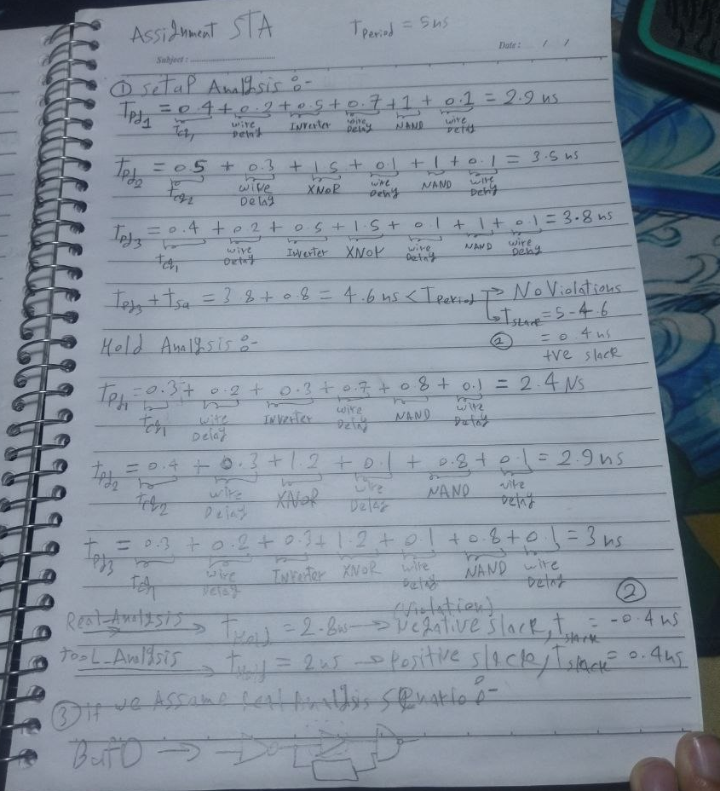
Figure A1: Original hand-written setup/hold timing analysis (scanned notes).

